Assignment 5.1: System Hardening and Compliance
Raymond Olmos
University of San Diego
CYBR-510-01B: Security Test Engineering
Professor Mark Heckman
October 04, 2026

Statement of Objective
The objective of this lab was to establish a baseline security-hardening posture for a Kali GNU/Linux Rolling virtual machine. A baseline Lynis audit was conducted to establish the initial Hardening Index, ten applicable CIS Benchmark-aligned configuration settings that were not already implemented were applied and verified, and a follow-up Lynis audit was performed to measure the resulting change in the Hardening Index. The procedures, configuration changes, verification results, and audit artifacts were documented so that another researcher could reproduce the baseline, hardening actions, and post-hardening assessment.
Theory
System hardening is the process of reducing a Linux system’s attack surface by applying secure configuration settings, limiting unnecessary access, protecting sensitive system files, and disabling services or kernel capabilities that are not required for the system’s intended use. The underlying principle is defense in depth: multiple independent configuration controls reduce opportunities for unauthorized access, information disclosure, misuse of system resources, and exploitation of unnecessary functionality.
CIS Benchmarks provide security-configuration recommendations that can be used as a structured hardening reference. Because Kali GNU/Linux Rolling is Debian-derived but uses a rolling-release model, CIS Debian Linux Benchmark recommendations were treated as a reference and applied only after confirming that each selected control was applicable to the test VM. The purpose was not to claim complete CIS compliance, but to implement ten appropriate configurations that were absent from the baseline system.
Lynis was used as the assessment mechanism because it examines local Linux configuration settings and reports warnings, suggestions, and a Hardening Index. The approach for this lab was to perform an initial Lynis audit to establish a controlled baseline, identify applicable CIS-aligned configuration gaps, apply and verify ten configuration changes and then repeat the audit on the same virtual machine with the same Lynis version. Holding the VM and assessment tool constant makes the before and after Hardening Index comparison a useful measure of the system’s change in hardening posture.
The selected controls were intended to reduce risk in several ways: restricting cron access limits who can schedule recurring jobs; login banners and post-login messages provide authorized-use notice while reducing unnecessary system-information disclosure. Core-dump restrictions reduce the risk that sensitive process memory will be written to disk; a restrictive default umask reduces unintended access to newly created files, and disabling unused DCCP, SCTP, RDS, and TIPC protocol modules reduces the availability of unnecessary network-related kernel functionality. Each control was verified after implementation so the final assessment reflected the intended configuration rather than unconfirmed change.
The Lynis Hardening Index is useful for comparing the same system before and after controlled changes, but it is not a direct percentage of security, a one-point-per-control scoring system, or proof of full CIS compliance. Some CIS-aligned controls may provide meaningful defense-in-depth benefits without materially changing the score, especially when they prevent future loading or misuse of components that were already inactive. Therefore, the final evaluation considers both the Hardening Index change and the verified security value of the ten implemented controls.

Description of Experimental Setup
The test environment consisted of a Kali GNU/Linux Rolling 2026.1 virtual machine hosted in Oracle VirtualBox. The VM hostname was kali, the architecture was x86-64, and the system used the Linux 6.19.14+kali-amd64 kernel. Kali is Debian-derived (ID_LIKE=debian) but operates as a rolling distribution, so the CIS Debian Linux Benchmark was used as a hardening reference after confirming individual recommendations were applicable to the Kali VM.
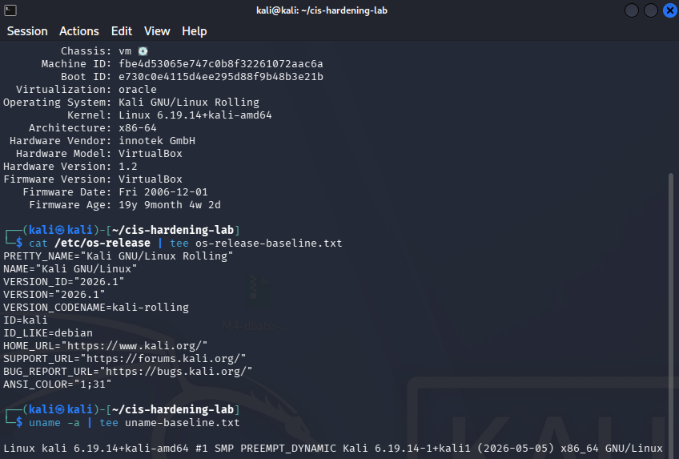
Figure 1. Kali Linux virtual-machine test environment. The test environment was a Kali GNU/Linux Rolling 2026.1 virtual machine running in Oracle VirtualBox. The VM used the Linux 6.19.14+kali-amd64 kernel and x86-64 architecture. Kali identifies as Debian-derived (ID_LIKE=debian), supporting the use of the applicable CIS Debian Linux Benchmark as a hardening reference.
Lynis version 3.1.6 was installed and used to establish the baseline security posture of the VM. Before any hardening modifications were made, the command sudo lynis audit system completed 268 tests and produced a baseline Hardening Index of 60.
Lynis displayed two environment-related notices: the installed Lynis version was more than six months old, and Kali Rolling was not included in the tool’s end-of-life database. These notices were recorded as assessment limitations. They do not prevent a valid comparison because the same Kali VM and Lynis version will be used for the post-hardening audit. The Hardening Index will be treated as a tool-specific before-and-after indicator, not as proof of complete CIS compliance.
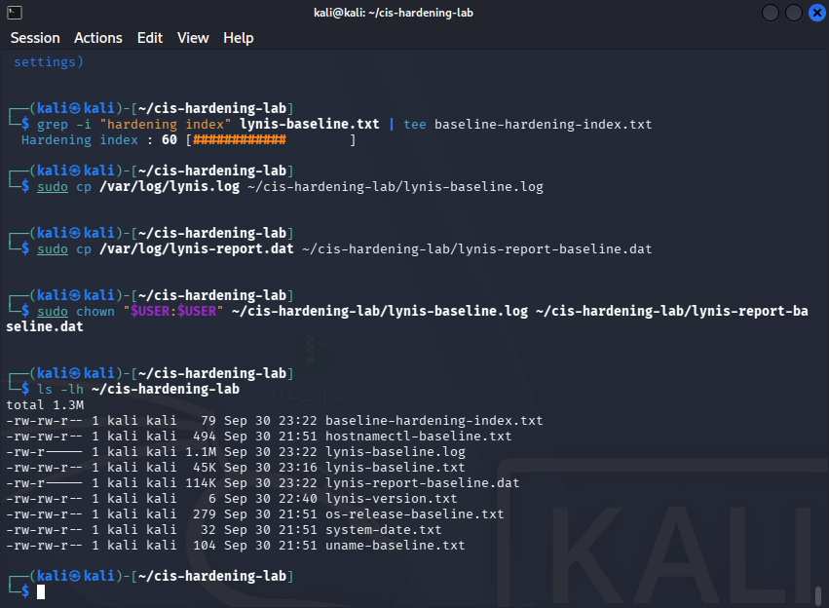
Figure 2. Baseline Lynis audit result. Lynis version 3.1.6 performed 268 audit tests on the Kali Linux VM before any CIS-aligned hardening changes were implemented. The initial Lynis Hardening Index was 60.

Procedure
To preserve the baseline state, the complete Lynis audit output was saved as lynis-baseline.txt. The Hardening Index was extracted into baseline-hardening-index.txt, and the Lynis log and report-data files were copied from /var/log/ into the experiment directory. File ownership was then assigned to the standard kali user so that the evidence could be reviewed and incorporated into the lab report.
Figure 3. Preservation of baseline Lynis audit evidence. The baseline Hardening Index of 60 was extracted into baseline-hardening-index.txt. The full Lynis terminal output, audit log, and machine-readable report data were retained in ~/cis-hardening-lab before hardening changes were made, supporting a reproducible comparison with the final audit.

Change 1: Restrict cron scheduler access
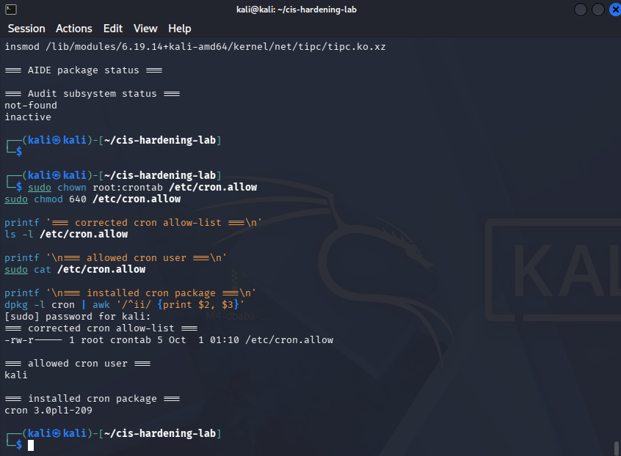
Figure 4. Cron scheduler access restriction. The baseline system had no explicit cron allow-list. The hardening change created /etc/cron.allow, set the final file owner to root:crontab with permissions of 640, ensured /etc/cron.deny was absent, and authorized only the kali account to schedule recurring cron jobs. The installed cron package was verified to confirm that the control applies to the test VM.
Note: After the initial configuration, the cron package and crontab group were verified. The /etc/cron.allow file ownership was updated to root:crontab and its permissions were updated to 640. This allows the cron scheduler group to read the allow-list while preventing access by unrelated local users. This refinement is part of Change 1 and was not counted as an additional hardening setting. The “at”scheduler was not installed on the test VM. An “at” allow-list was not included in the final count of ten applied hardening configurations.
Change 2: Configure the local login warning banner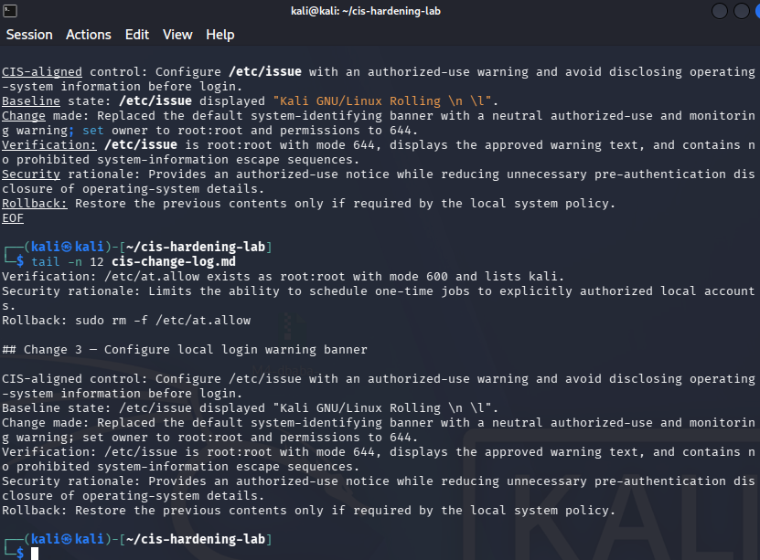
Figure 5. Local login warning banner configuration. The default /etc/issue banner disclosed Kali operating-system information before authentication. The banner was replaced with an authorized-use and monitoring notice, retained root:root ownership and mode 644, and was verified to contain no system-information escape sequences.

Change 3: Configure remote login warning banner
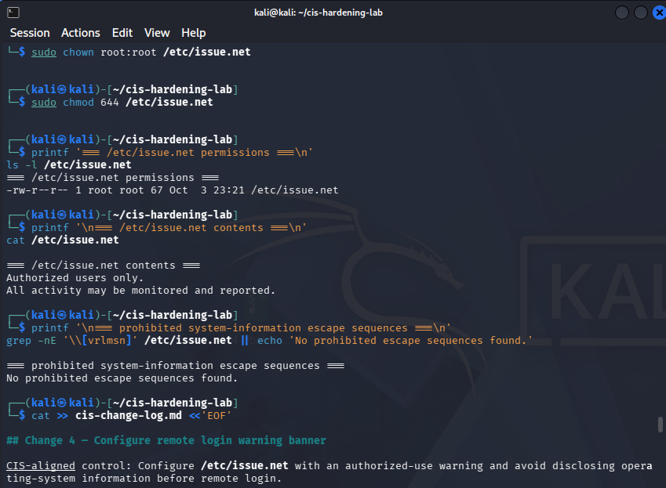
Figure 6. Remote login warning banner configuration. The default /etc/issue.net banner disclosed Kali operating-system information before remote authentication. The file was replaced with an authorized-use and monitoring notice, set to root:root ownership with mode 644, and verified to contain no system-information escape sequences.
Change 4: Restrict core dumps
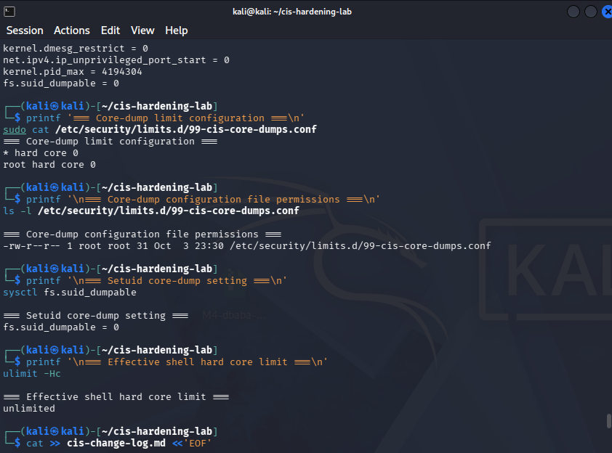
Figure 7. Core-dump restriction configuration. A later-loading limits configuration was created to enforce a hard core-dump limit of zero for regular users and root. The fs.suid_dumpable kernel parameter was set to zero, preventing setuid programs from producing core dumps and reducing the risk of sensitive process-memory disclosure.
Change 5: Configure a restrictive default umask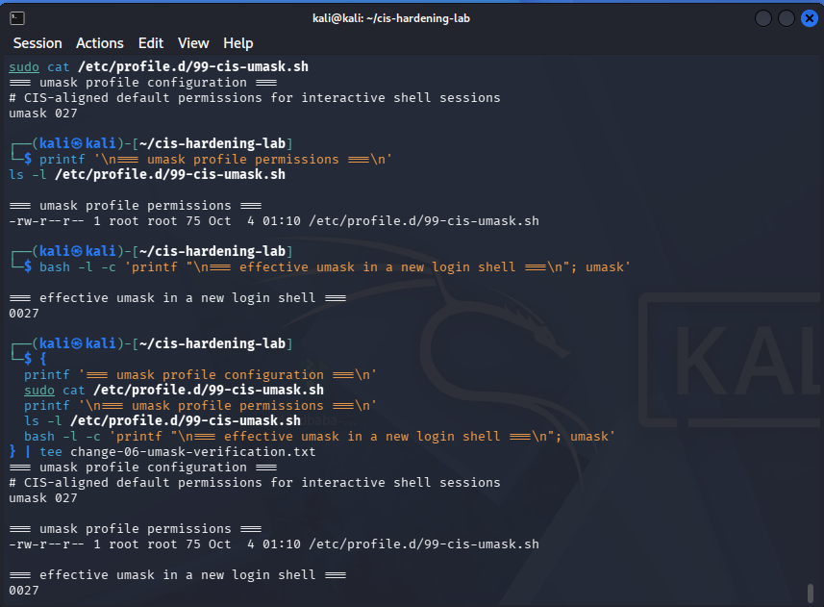
Figure 8. Restrictive default umask configuration. A dedicated profile script was created to enforce umask 027 for new interactive login shells. The script is owned by root:root with mode 644, and a new login shell verified the effective setting as 0027, limiting default access to new files and directories.
Change 6: Configure the /etc/motd post-login message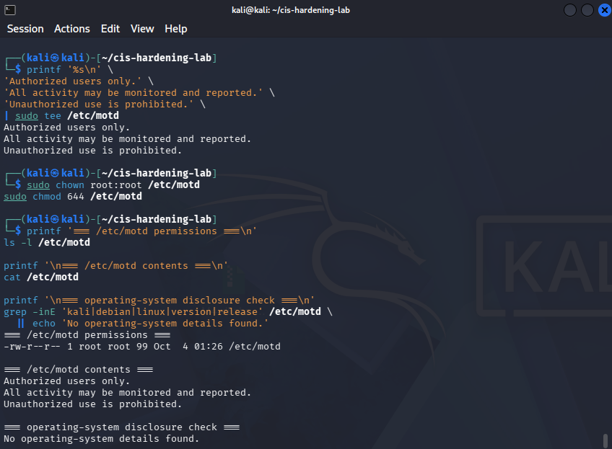
Figure 9. Post-login message configuration. The default /etc/motd disclosed Kali GNU/Linux branding and warranty information after login. It was replaced with a neutral authorized-use notice, retained root:root ownership and mode 644, and was verified not to disclose operating-system details.
Change 7: Disable DCCP
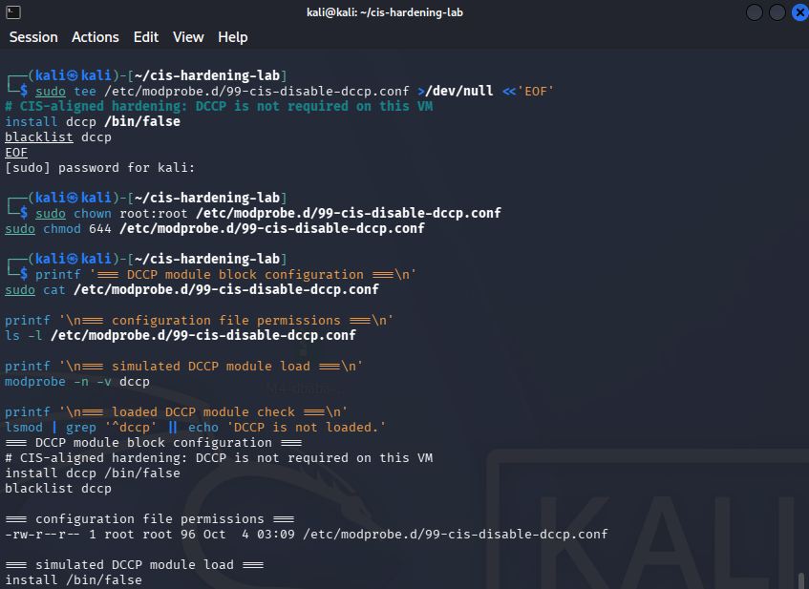
Figure 10. DCCP kernel-module restriction. DCCP was available but unused on the Kali VM. A modprobe configuration prevented DCCP from loading by directing module-load requests to /bin/false and blacklisting the module. Verification confirmed that DCCP remained unloaded.
Change 8: Disable SCTP
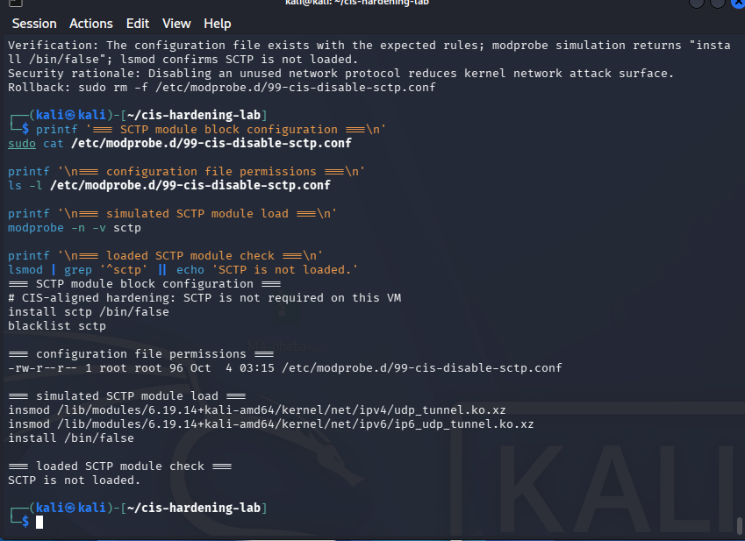
Figure 11. SCTP kernel-module restriction. SCTP was available but unused on the Kali VM. A modprobe configuration prevented SCTP from loading by directing module-load requests to /bin/false and blacklisting the module. Verification confirmed that SCTP remained unloaded.
Change 9: Disable RDS
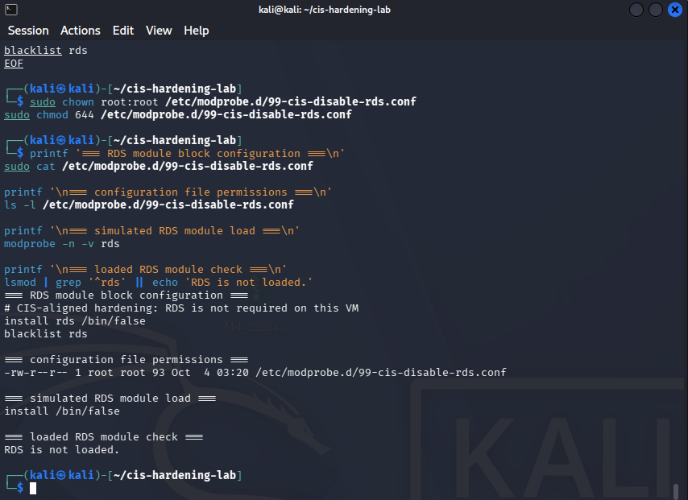
Figure 12. RDS kernel-module restriction. RDS was available but unused on the Kali VM. A modprobe configuration prevented RDS from loading by directing module-load requests to /bin/false and blacklisting the module. Verification confirmed that RDS remained unloaded.
Change 10: Disable the TIPC protocol module
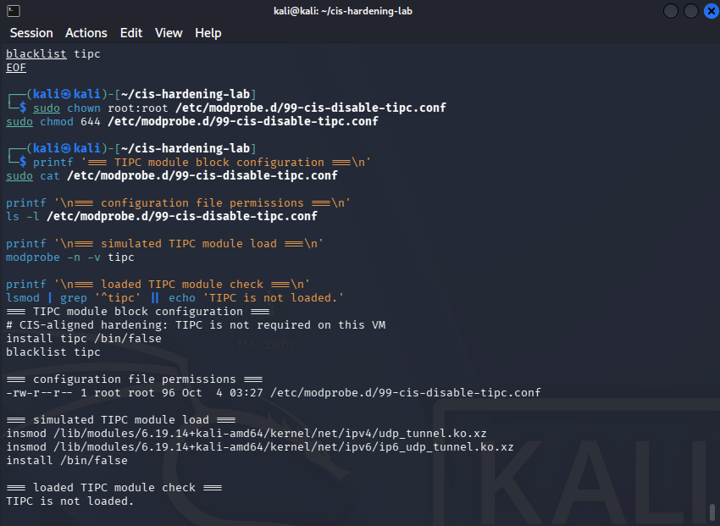
Figure 13. TIPC kernel-module restriction. TIPC was available to load but was not required or loaded on the Kali VirtualBox VM. A modprobe configuration file, /etc/modprobe.d/99-cis-disable-tipc.conf, was created with an install tipc /bin/false rule and a blacklist tipc entry. The configuration was verified as owned by root:root with mode 644; a simulated module-load request returned install /bin/false, and lsmod confirmed that TIPC was not loaded.

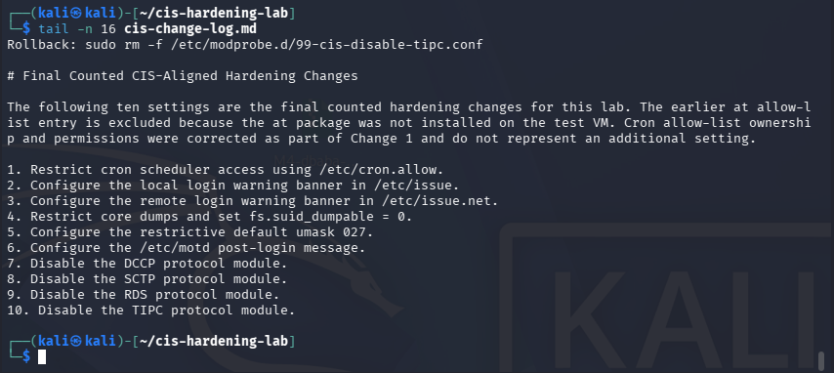
Figure 14. Final counted CIS-aligned hardening configuration summary. The final section of cis-change-log.md documents the ten configuration settings counted for the lab: cron scheduler access restriction, local and remote login banners, core-dump protection, restrictive default umask, post-login message configuration, and disabling the unused DCCP, SCTP, RDS, and TIPC protocol modules. The log also documents that the earlier “at” allow list was excluded because the “at” package was not installed and that the cron file-permission adjustment was part of Change 1 rather than an additional change.

Hardening Change Summary Table
# | CIS-aligned setting | Final configuration / verification
1 | Restrict cron scheduler access | /etc/cron.allow contains kali; final owner/group root:crontab; mode 640; /etc/cron.deny absent
2 | Configure local login banner | /etc/issue contains an authorized-use notice; owner root:root; mode 644
3 | Configure remote login banner | /etc/issue.net contains an authorized-use notice; owner root:root; mode 644
4 | Restrict core dumps | /etc/security/limits.d/99-cis-core-dumps.conf sets hard core limits to 0; fs.suid_dumpable = 0
5 | Set restrictive umask | /etc/profile.d/99-cis-umask.sh sets umask 027; new login shell verifies 0027
6 | Configure post-login message | /etc/motd contains a neutral authorized-use notice; owner root:root; mode 644
7 | Disable DCCP | /etc/modprobe.d/99-cis-disable-dccp.conf uses install dccp /bin/false; module not loaded
8 | Disable SCTP | /etc/modprobe.d/99-cis-disable-sctp.conf uses install sctp /bin/false; module not loaded
9 | Disable RDS | /etc/modprobe.d/99-cis-disable-rds.conf uses install rds /bin/false; module not loaded
10 | Disable TIPC | /etc/modprobe.d/99-cis-disable-tipc.conf uses install tipc /bin/false; module not loaded

The above table summarizes the final ten counted hardening settings. Each configuration was first checked to confirm that it was not already configured as required, then changed, verified, documented in cis-change-log.md, and retained in the lab evidence directory.
Data
Table 1. Baseline Data Table
Measurement | Baseline result | Supporting evidence
Operating system | Kali GNU/Linux Rolling 2026.1 | Figure 1
Distribution family | Debian-derived (ID_LIKE=debian) | Figure 1
Virtualization platform | Oracle VirtualBox | Figure 1
Kernel | Linux 6.19.14+kali-amd64 | Figure 1
Architecture | x86-64 | Figure 1
Lynis version | 3.1.6 | Figure 2
Lynis tests performed | 268 | Figure 2
Baseline Hardening Index | 60 | Figures 2 and 3
Baseline evidence directory | ~/cis-hardening-lab | Figure 3

Figures 1 through 3 document the system identity, baseline audit result, and preservation of the baseline evidence. These artifacts establish the pre-hardening condition against which the final Lynis scan will be compared.

Table 2. Hardening change summary.
Measurement | Baseline | Post-hardening | Difference
Lynis Hardening Index | 60 | 62 | +2
CIS-aligned settings implemented | 0 | 10 | +10
Lynis version | 3.1.6 | 3.1.6 | No change
Test system | Kali GNU/Linux Rolling 2026.1 | Kali GNU/Linux Rolling 2026.1 | Same VM

The post-hardening Lynis scan was performed using the same Kali GNU/Linux Rolling 2026.1 VM and Lynis version 3.1.6 used for the baseline assessment. The system’s Hardening Index increased from 60 to 62 after the ten CIS-aligned changes were applied. The baseline and final audit logs and report-data files were preserved in the lab evidence directory for reproducibility.
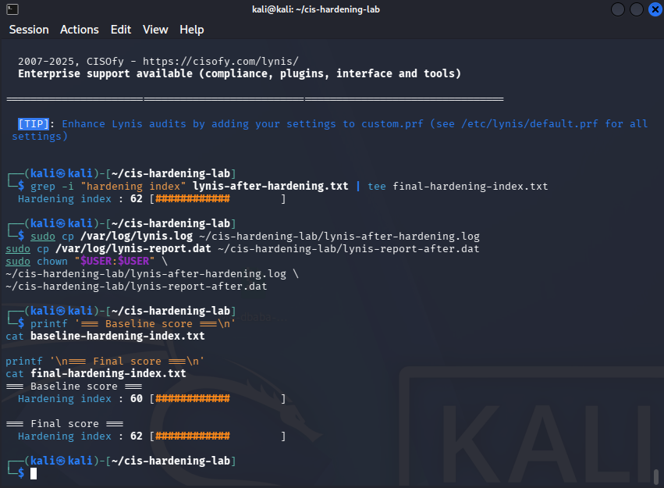
Figure 15. Lynis Hardening Index Comparison. The baseline Lynis audit produced a Hardening Index of 60. After the ten counted CIS-aligned hardening configurations were implemented and verified, the final Lynis audit produced a Hardening Index of 62, representing a two-point improvement.
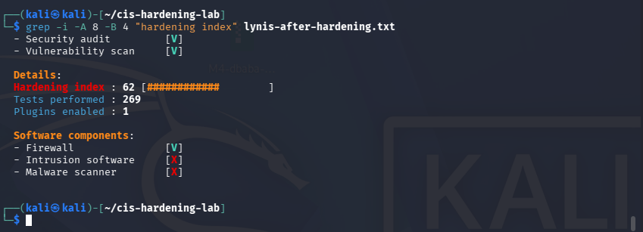
Figure 16. Post-hardening Lynis audit result. Lynis was rerun after the ten CIS-aligned hardening configurations were applied and verified. The post-hardening audit reported a Hardening Index of 62, compared with the baseline score of 60.
Analysis of Data and Conclusions
The baseline Lynis audit produced a Hardening Index of 60. After applying ten CIS-aligned hardening configurations, the final Lynis audit produced a Hardening Index of 62. The two-point increase demonstrates that the VM’s measurable hardening posture improved. However, the increase was substantially smaller than a one-point-per-change expectation. This outcome was not unexpected because the Lynis Hardening Index is not a direct CIS-compliance percentage and does not assign a fixed-point value to every configuration change.
Several of the completed controls were primarily preventive or policy-oriented rather than settings heavily weighted by Lynis. For example, the local and remote banners, post-login message, cron access allow-list, restrictive default umask, and kernel protocol module restrictions improve security posture and support CIS-aligned configuration management, but the installed version of Lynis may not score each control individually. In particular, DCCP, SCTP, RDS, and TIPC were already unloaded before the hardening actions; the changes prevented future loading of those unused modules, which improves defense in depth but may not substantially change Lynis’s score.
The core dump restrictions were particularly significant because core files can contain application memory and sensitive information. The configuration set hard core-dump limits to zero and set fs.suid_dumpable to zero, preventing setuid programs from generating core dumps. The restrictive umask 027 was also valuable because it reduces the likelihood that newly created files or directories are accessible to unrelated local users.
The two-point improvement was modest but meaningful. It shows that the same Lynis version detected an improved hardening posture on the same Kali VM after the configuration changes were applied. The result was lower than a simple one-point-per-change expectation because Lynis does not measure every CIS-aligned configuration or weight every control equally. Several changes, especially the DCCP, SCTP, RDS, and TIPC restrictions, improved defense in depth by preventing future loading of protocols that were already unloaded. Therefore, their security value was greater than their apparent effect on the numeric score.
The most significant changes were the core-dump restrictions, the restrictive default umask, and the cron allow-list because they directly reduce potential information disclosure, excessive default file access, and unauthorized task scheduling. The banner and message changes provided clear authorized-use warnings and reduced unnecessary system-identifying information. Overall, the lab demonstrated that a Hardening Index is useful for measuring change over time, but it is not a direct measure of full CIS compliance or total system security. Future hardening work could include reviewing remaining Lynis warnings, enabling integrity monitoring or audit logging where operationally appropriate, and periodically repeating the audit after system updates.

